Lesson 12

Variable and Function Scope
When using variables from within a program you need to be aware of the scope of the variables and functions. This can sometimes be used to good effect when writing functions but does need to be used with care. Within scope of a class a function can be made public or private to the class this is one of the ways to make a function have limited scope. All functions need to be declared before they are used. In a similar way the scope of a variable is from its declaration to the end of the class, unless that variable is marked as a public member of the class. If a variable is declared within a set of curly brackets of function or a sub block of code, then the scope of the variable will only be for that block of code. This can be used to good effect, if a variable is declared with the same name inside two or more functions then the instances of each variable will not interfere with the other functions variable of the same name. This very same feature also means that when a function has finished, then the variable is no longer in scope and is therefore it no longer needs to use memory. The result of which is that the memory used to store the variable is then freed. All variables must be declared before it is used, and all variables have to be initialised before use.

Example code
The example code is a Windows application for Visual J++ but should be easily adapted for use with other Java tools.
import com.ms.wfc.app.*;
import com.ms.wfc.core.*;
import com.ms.wfc.ui.*;
import com.ms.wfc.html.*;
import com.ms.wfc.util.*;

// Lesson12.java.
//

/**
* This class can take a variable number of parameters on the command
* line. Program execution begins with the main() method. The class
* constructor is not invoked unless an object of type 'Form1' is
* created in the main() method.
*/
public class Form1 extends Form
{
/* the following Line will give a compile error
* since it uses i which is not yet in scope
* If the comment markers are removed this will cause compile error
*/
//int A = i * 21;
int i= 10;
//Modified constructor to pass the main arguement list
public Form1(String args[])
{
// Required for Visual J++ Form Designer support
initForm();
label1.setText("Start:-\n\n");
AddLine("Variable i Value = " + i );
{
int i;
/* the line below gives an error fix line above */
AddLine("Variable i Value in loop = " + i);
AddLine("Hello World!");
for(i=0;i<args.length;i++)
{
AddLine("Argument Number "+i + " : "+args[i]);
FunctionA();
}
AddLine("Variable i Value in loop = " + i);
}
AddLine("Variable i Value = " + i );
}

/**
* Form1 overrides dispose so it can clean up the
* component list.
*/
public void dispose()
{
super.dispose();
components.dispose();
}
void AddLine(String strtext)
{
Add(strtext+ "\n") ;
}
void Add(String strtext)
{
String temp = label1.getText() + strtext ;
label1.setText(temp);
}
/* Name : FunctionA1
* Input : None
* Return : None
*/
void FunctionA1()
{
AddLine("Before Loop FunctionA1 i= "+i);
{
int i;
for(i=0;i<3;i++)
Add("FunctionA1 i= "+i+",");
AddLine("End of Loop FunctionA1 i="+ i );
}
AddLine("After Loop FunctionA1 i="+ i + "\n");
}
/* Name : FunctionA
* Input : None
* Return : None
* Comments: This Function is be used by Form Constructor
*/
void FunctionA()
{
AddLine("FunctionA Before Loop i=" + i);
{
int i;
for(i=0;i<3;i++)
Add("FunctionA i=" +i + ":");
AddLine("End of Loop FunctionA i=" + i);
}
AddLine("After Loop FunctionA i=" + i +"\n");
FunctionA1();
}
private void Form1_resize(Object source, Event e)
{
Point frameSize = getClientSize();
label1.setLocation(5,5);
label1.setSize(frameSize.x-10,frameSize.y-10);
}

/**
* NOTE: The following code is required by the Visual J++ form
* designer. It can be modified using the form editor. Do not
* modify it using the code editor.
*/
Container components = new Container();
Label label1 = new Label();

private void initForm()
{
this.setText("Lesson 12: Variable Scope ");
this.setAutoScaleBaseSize(new Point(5, 13));
this.setClientSize(new Point(794, 493));
this.addOnResize(new EventHandler(this.Form1_resize));

label1.setAllowDrop(true);
label1.setLocation(new Point(8, 8));
label1.setSize(new Point(784, 480));
label1.setTabIndex(0);
label1.setTabStop(false);
label1.setText("label1");
label1.setBorderStyle(BorderStyle.FIXED_3D);

this.setNewControls(new Control[] {
label1});
}

/**
* The main entry point for the application.
*
* @param args Array of parameters passed to the application
* via the command line.
*/
public static void main(String args[])
{
//Pass args to Form1
Application.run(new Form1(args));
}
}

Setting the program arguments
For Visual J++ the calling arguments are set in the project properties. Select the Launch tab and then select the Custom option. Most of the launch command should be entered automatically the additional parameters of One two three need adding to the arguments.
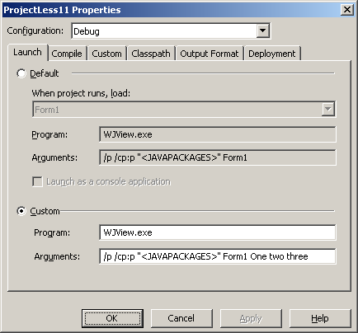
For J Builder the calling arguments are set in project properties on the Run/ debug tab. In this tab there are various places for text that is to be used by the program. The parameters text is the parameters that will be passed to the program when it is running.
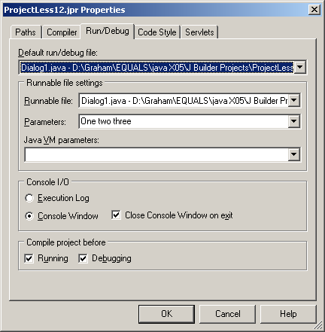
Alternatively the in the command window it is possible to type the program exe followed by the parameters. See the line shown in screen shot that follows of the command window.
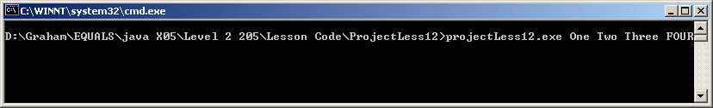
The final method is the write a batch file such as “TestLess12.bat” that contains the following line.
ProjectLess12.exe One two three

Screen shot of running program
The screen shot that follows shows the output created when the application arguments are set as “One two three”
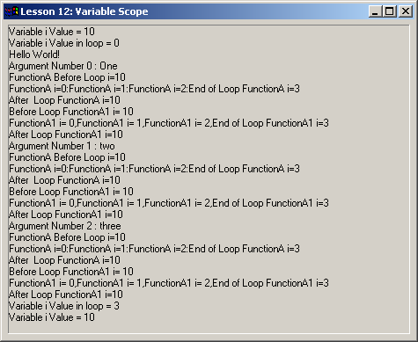

Exercise
Try the code above and see the effect of removing some of the
int i;
statements from the code. NOTE well the code will not run in a way that was expected. Note the effects in the table that follows when the statements are missing from the different combinations of subroutines.

 | Class | Form1 constructor | FunctionA | FunctionA1
Class

Form1
Constructor

FunctionA

FunctionA1

